Problem no : 2302056_01

Problem Name : Print name, DOB, and mobile number

Input :

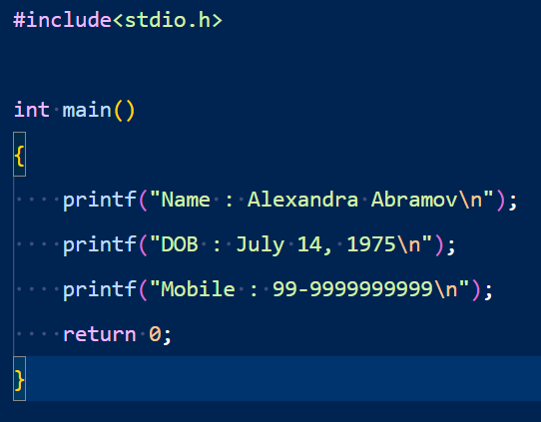

Output :

Problem No : 2302056_02

Problem Name : Write a C program to get the C version you are using.

Input :

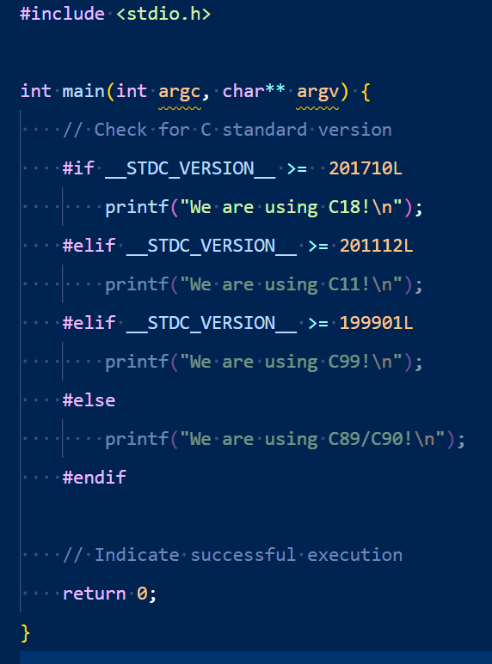

Output :



Problem No : 2302056_03

Problem Name : Write a C program to print a block F using the hash (#), where the F has a height of six characters and width of five and four characters. And also print a very large 'C'.

Input :

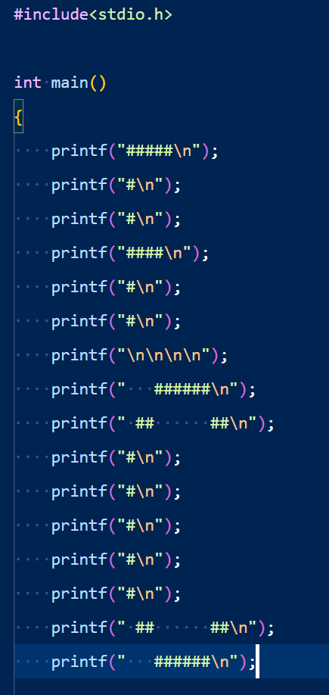

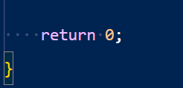

Output :

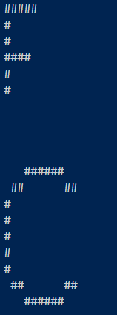

Problem No : 2302056_04

Problem Name : Write a C program to print the following characters in reverse.  
*Test Characters*: 'X', 'M', 'L'

Input :

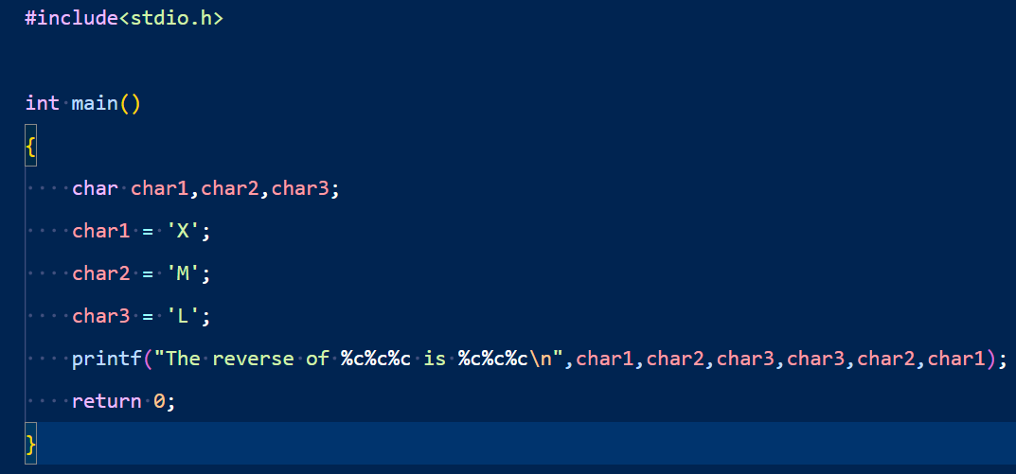

Output :



Problem No : 2302056_05

Problem Name : Write a C program to compute the perimeter and area of a rectangle with a height of 7 inches and width of 5 inches.

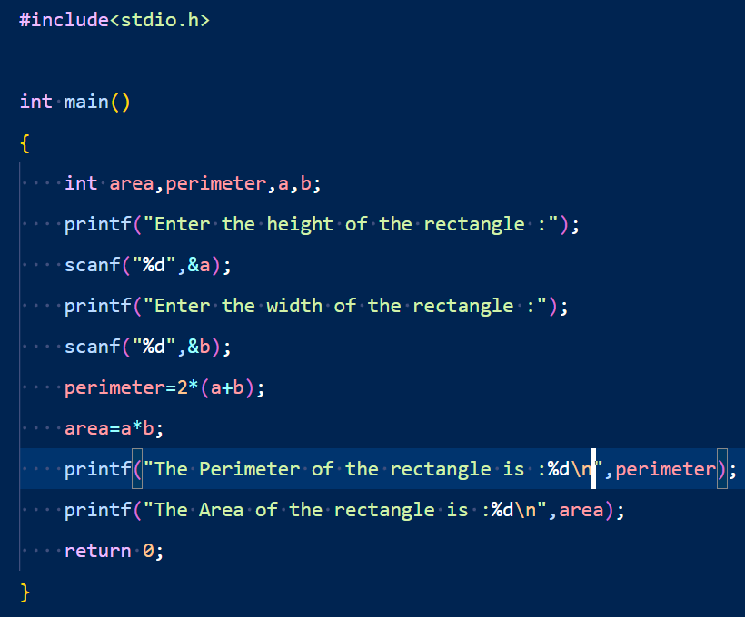

Output :

Problem No : 2302056_06

Problem Name : Write a C program to compute the perimeter and area of a circle with a given radius.

Input :

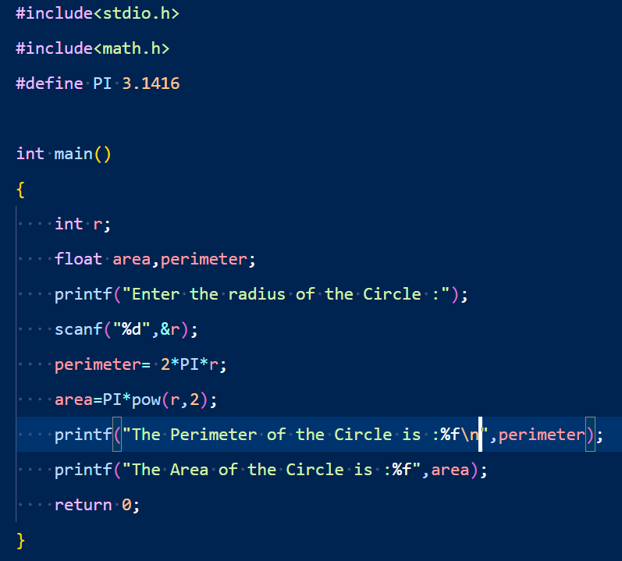

Output :

